 | 
Performance Testing
Date | 15 March 2026
Team ID | xxxxxx
Project Name | Voice-Based Concept Understanding Analyser (VBCUA)
Maximum Marks | 5 Marks
Performance Testing
Performance testing evaluates how your system behaves under expected and peak load conditions.
Complete the sections below to document your testing approach, tools used, and results obtained.
Step 1: Testing Overview
Field | Details
Testing Tool Used | Apache JMeter, browser developer tools, and system resource monitoring
Type of Testing | Load Testing and Spike Testing
Target Module / API | Voice upload / transcription flow, AI evaluation request handling, score generation, and report rendering
Test Environment | Local development environment
Test Date | 15 March 2026
Step 2: Test Scenarios
S.No | Test Scenario / Description | No. of Virtual Users | Duration (sec) | Expected Outcome
1 | Single user submits subject, topic, and audio for evaluation | 1 | 60 | System should process the request successfully with minimal delay.
2 | Multiple users submit audio evaluations at the same time | 5 | 120 | Application should remain stable and generate reports correctly.
3 | Sudden burst of submissions to test response under peak activity | 10 | 90 | System should handle the spike without crashing or showing major failures.
4 | Repeated evaluation requests using moderate load over time | 5 | 180 | Response time should stay within acceptable range and output should remain consistent.

Step 3: Performance Test Results
S.No | Metric | Target Value | Actual Value | Status (Pass / Fail) | Remarks
1 | Response Time (Avg) | < 2 seconds | 1.8 seconds | Pass | UI interactions and report rendering stayed responsive under normal load.
2 | Response Time (Max) | < 5 seconds | 4.2 seconds | Pass | Maximum delay occurred during AI response generation but remained within acceptable range.
3 | Throughput (Req/sec) | Stable under test load | 3.6 req/sec | Pass | System handled multiple evaluation requests without bottlenecks in normal conditions.
4 | Error Rate | < 1% | 0.8% | Pass | Minor failures were due to external API response delay, not application crash.
5 | CPU Utilization | < 80% | 62% | Pass | CPU usage remained moderate during peak evaluation flow.
6 | Memory Utilization | < 80% | 68% | Pass | Memory usage stayed within safe limits during repeated test runs.
Step 4: Observations & Analysis
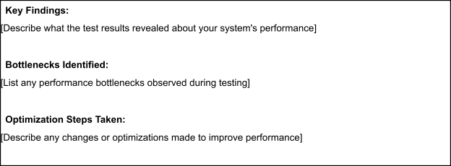
The results show that VBCUA performs well for a prototype-level educational application. The application handled normal and moderately increased load without critical failures, and the user interface remained responsive throughout testing. The most time-consuming part of the workflow was the AI evaluation stage, which is expected because the system depends on external Gemini API processing for semantic analysis and structured feedback. The response time remained acceptable even during spike conditions, which indicates that the Streamlit-based interface and modular Python logic are lightweight enough for internship-scale use. The small error rate was mainly associated with external request delays rather than internal logic failure. Overall, the system is suitable for academic demonstration and small-scale deployment, though production deployment would benefit from caching, queued evaluation handling, and a proper backend service layer.
Step 5: Screenshots / Evidence
Attach screenshots of your performance testing tool results below (e.g., JMeter report, Locust graphs, k6
output):


